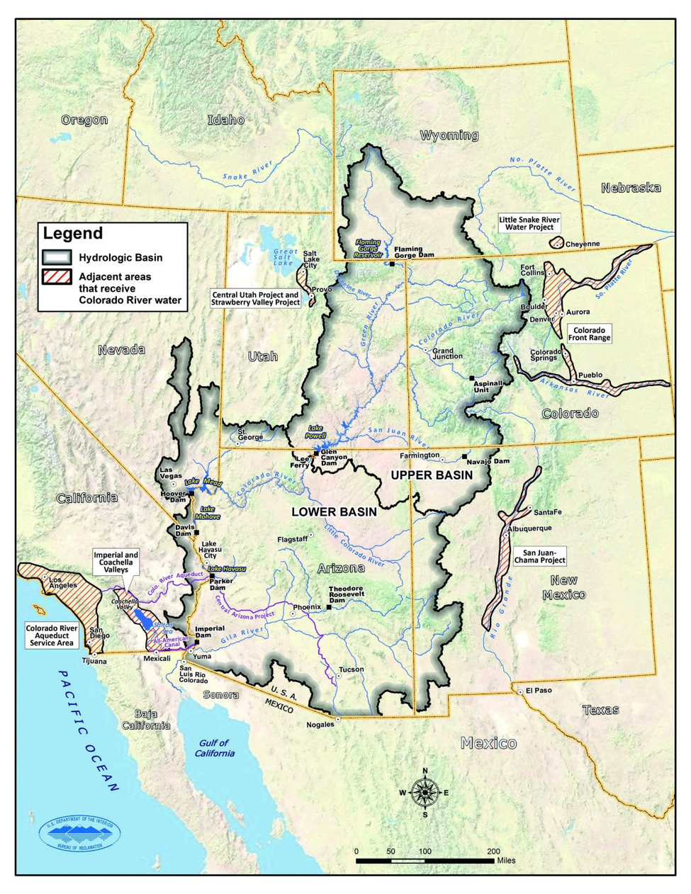

Immersive Modeling for Lake Mead based on the Principle of Division of Reservoir Inflow

Talha Quddoos- A02469393
Dr. David E. Rosenberg
CEE 6410- Civil Engineering Systems Analysis in the Age of Uncertainty
September 13, 2026

Introduction
This report is based on an immersive class activity done to model water usage for a hypothetical drought condition. The model used for this activity was “Immersive Model for Lake Mead based on the Principle of Divide Reservoir Inflow” (Rosenberg 2024). Participants of this activity personified as representatives of California, Nevada, Mexico, Arizona, the U.S. Bureau of Reclamation, and First Nations to discuss and negotiate their water usage against declining water in the Colorado River basin to increase the local managers' flexibility regarding water consumption/conservation and to keep the water level of Lake Mead from falling below critical levels. This report is documented by Talha, who acted as the representative of Arizona for Group A's group activity. This one pager report presents the activity from Arizona’s perspective.

Description
This class activity was done to model water scarcity situation for Colorado River Basin. Participants did a hand-on activity in which lowest Lake Mead inflow conditions were considered as a baseline to navigate a collaborative decision-making process of the stakeholder states, Mexico and Tribal Lands.
In the modeling activity, the storage value of 1025 maf was decided to represent the physical watershed storage present, and Lake Mead Level was set at 1020 feet as a Reclamation Zone (5.9 maf), from the projected data of 2022 (Fig.1). The evaporation value of 6 maf/year was decided from the Lake Mead Evaporation (maf / year) vs Active Storage (maf) graph (Fig.2). This resulted in an Inflow of 3.8maf in the year 1 which is a lot less from the historical values of Lake Mead Inflow (Fig4).
The primary management strategy for the state of Arizona was to continue the mandatory water conservation to cut back water usage from 2.8 million acre feet (maf), buy water to reduce mandatory conservation, and to save up water for the future.
Year 1: The model calculations based on mutual agreement of all the stakeholders resulted in a share of 0.75maf for the state of Arizona. Colorado River constitutes 36% of Arizona water supply. The available water share fell short by 0.23 maf (2.8*0.35- 0.75). Considering this situation, Arizona decided to.
- Buy any available water anyone is willing to sell. Since other parties were willing to sell only 0.01maf Arizona decided to buy it against a price of $175 per acre feet resulting in compensation of $2 million.
- Make policies to reduce water usage i.e to monitor water usage and to impose taxes on excessive water usage.
- Since Agriculture takes most of the water share i.e 75%, Arizona decided to introduce policies regarding promoting less water consuming crops and to promote and invest in drought resistant seeds.
At the end of the year 1, Lake Mead had 5.6maf water.
Year 2: Year 2 started great with Arizona water share as 1.2maf which was 0.395maf more than the supply share Arizona needs from Colorado River i.e. (2.3*.35=0.805maf). This year Arizona decided to
- Since Arizona got plenty of water this year, it decided to rely on this water source more to replenish the other water sources it relied on the previous year.
- Sell the same volume of water it bought the previous year to balance its finances.

Conclusion and Recommendations
Based on the adopted policies by Arizona and other stakeholder states, there was a decline in the elevation of Lake Mead by 1 feet with a storage of 5.6 maf at the end of the year. Second year conditions improved Lake Mead level significantly to 1031.5 feet elevation and 6.4 maf. Based on the results of this modelling activity and considering the water utilization in the state of Arizona it is recommended that agriculture sector should be monitored and regulated for water consumption, and more work should be done in developing drought resistant crops (since agriculture consumes the major share of water in Arizona)
This model, although simplified a lot of information, it helped in replicating a real-life engineering situation to the participants.The students got to know how to work together to reach collaborative goals.

Data Availability
- Model Repository: https://github.com/dzeke/ColoradoRiverCollaborate/tree/main/LakeMeadWaterBankDivideInflow
- Google sheets Workbook: https://docs.google.com/spreadsheets/d/1Kp7I1QZbd1PgueNnxcVtjCpDHbhLbnju/edit?gid=329242727#gid=329242727
- Group A Running Notes:
https://docs.google.com/document/d/1e5t1M7b969HyupDt7fUp-o71ehOiGjRG/edit

Use of Artificial Intelligence (AI)
No AI was used in the analysis or writeup.

References
Rosenberg, D. E., Myers, A., Akbar, H., & Porse, E. (2025). Immersive model for Lake Mead based on the principle of division of reservoir inflow. Utah State University.

USBR. (2012). "Colorado River Basin Water Supply and Demand Study." U.S. Department of Interior, Bureau of Reclamation, Washington, D.C.,

USBR. (2019). "Agreement Concerning Colorado River Drought Contingency Management and Operations." U.S. Bureau of Reclamation, Washington, DC. https://www.usbr.gov/ColoradoRiverBasin/dcp/index.html.

Appendices

Colorado River Basin Map
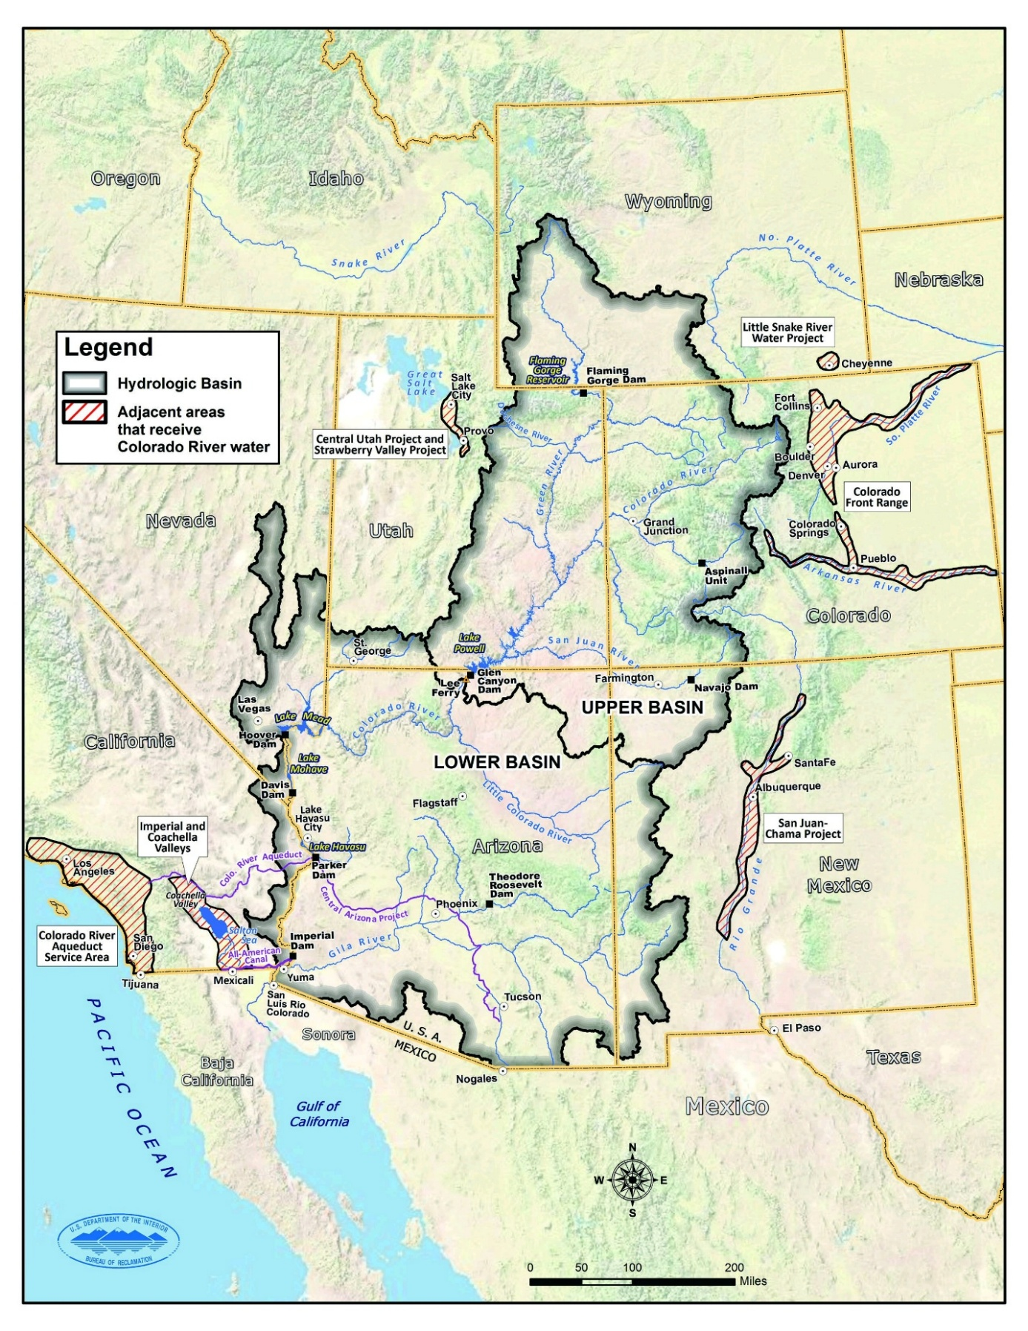
Figure 1 Colorado River Basin Map (USBR 2012)

Group Members and their Roles
Table 1: Group Members and Roles
Reclamation - Protect Zone | Sam
California | Maddie
Arizona | Talha
Nevada | Sam
Mexico | Lan
Tribal Nations of the Lower Basin | Maddie
Running Notes | Dr. Rosenberg

Lake Mead Storage and Evaporation
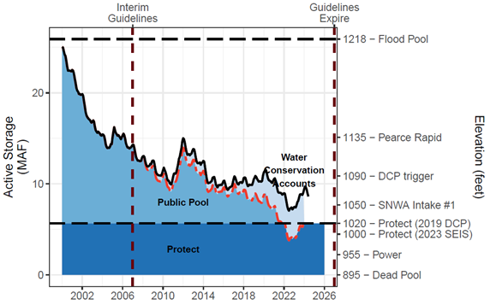
Figure 2 Lake Mead Storage (solid black line), Water Conservation (ICS) Account Balances (light blue fill), and anticipated lake volume absent the water conservation program (dashed red line). Conservation program kept lake elevation above 1020 feet in 2022.
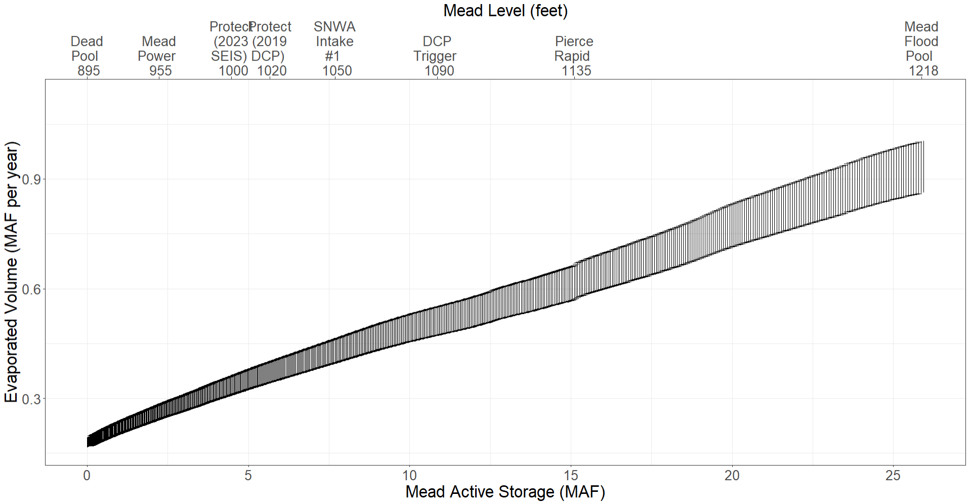
Figure 3 Lake Mead Evaporation (maf / year) vs Active Storage (maf)
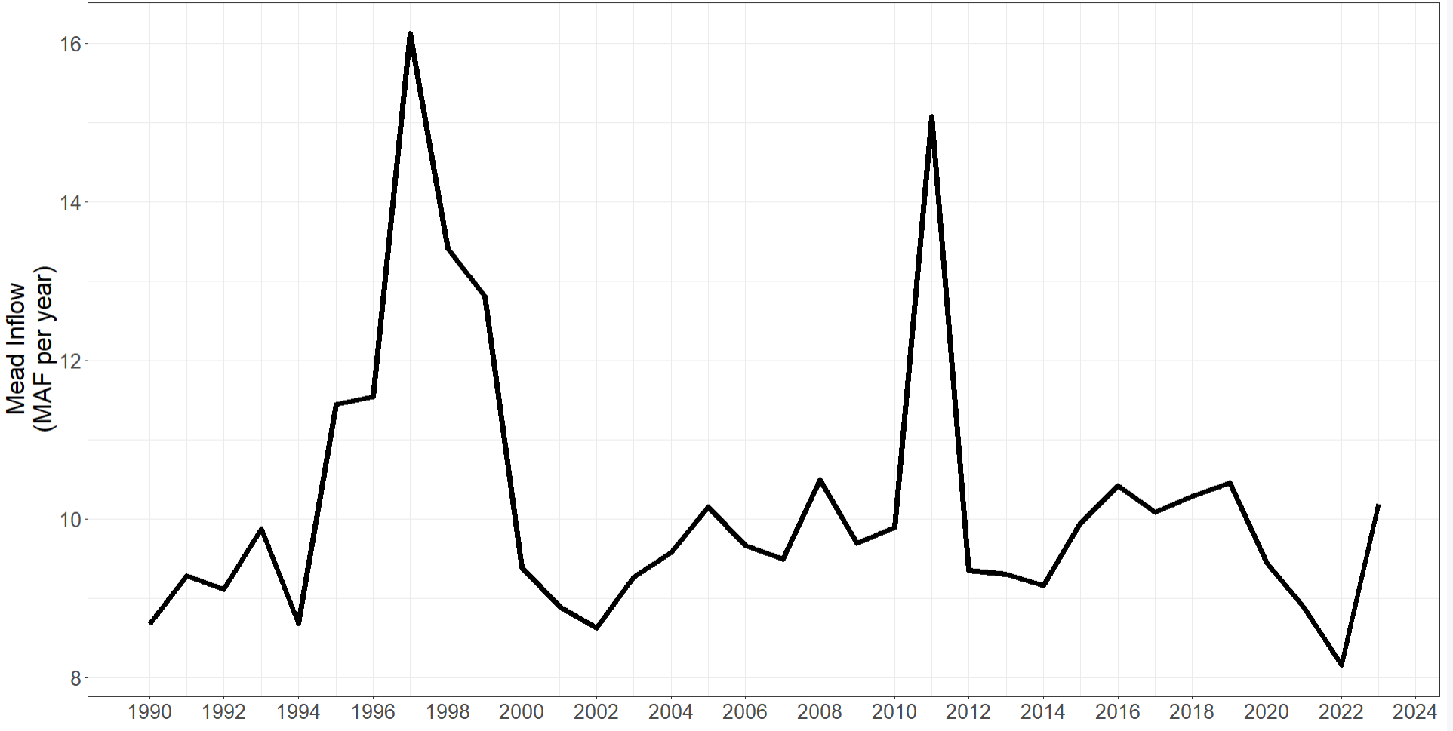
Figure 4 Lake Mead Historic Inflow
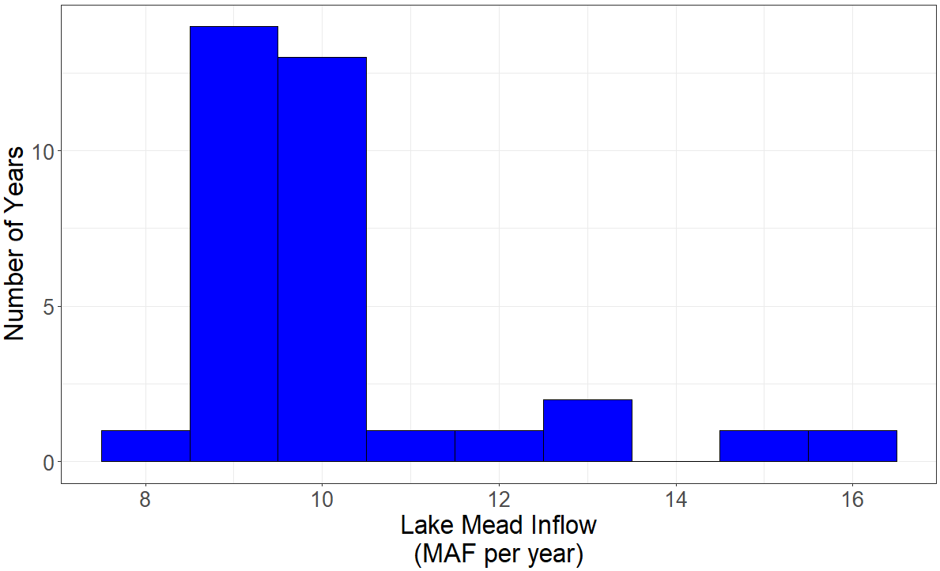
Figure 5 Lake Mead Inflows Histogram

Arizona Water Supply and Water Use
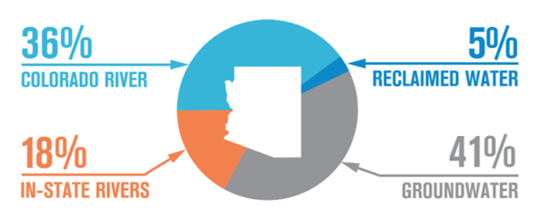
Figure 6 Water source split for Arizona
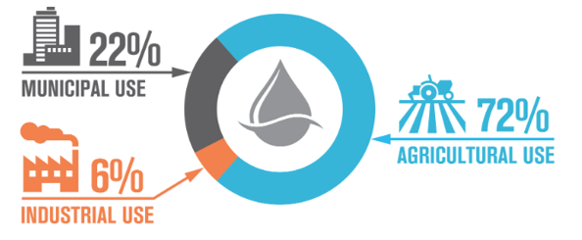
Figure 7 Water utilization for Arizona

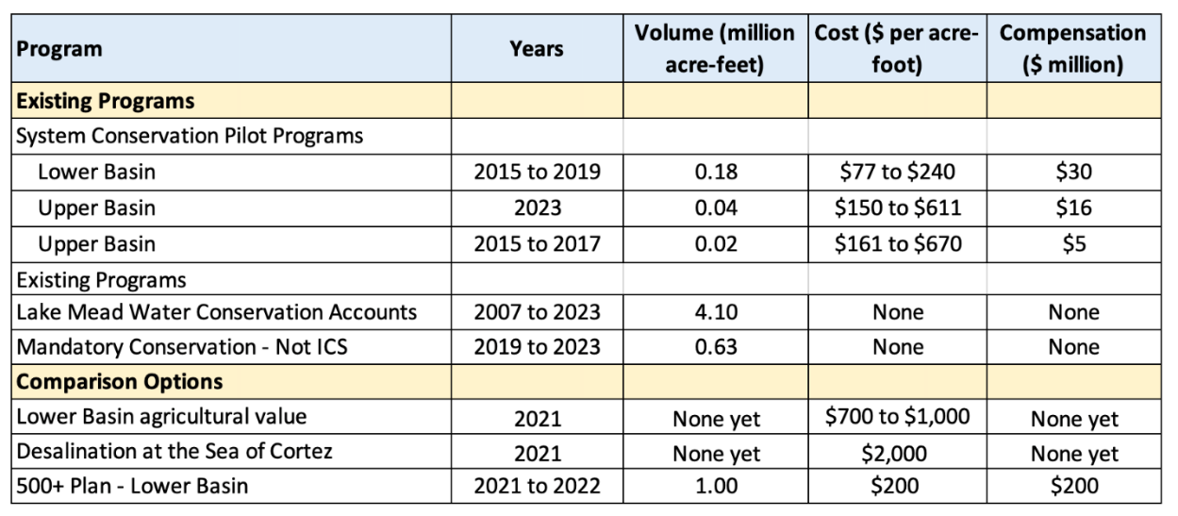
Figure 8 Compensation history for Lake Mead Inflow.

Model Outputs
Table 2 Model conditions and corresponding Lake Mead Inflow for activity years.
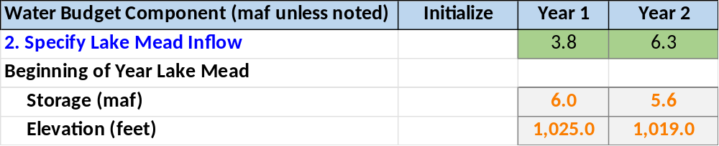
Table 3 Model conditions and corresponding Lake Mead Inflow for activity years.
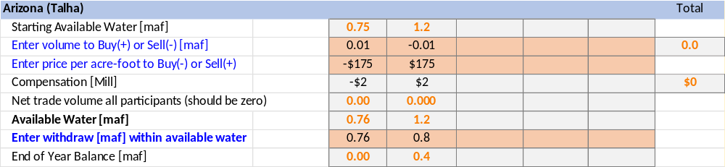
Table 4 Lake Mead end of year summary
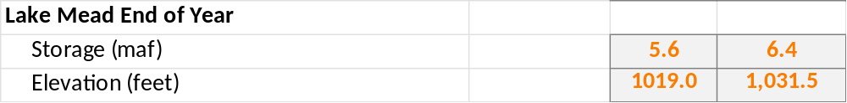

Figure 9 Dynamic water storage plot for GroupA activity.

Category  (Max. Score) | No Evidence | Doesn’t Meet Standard | Nearly Meets Standard | Meets Standard | Exceeds Standard | Self- Score | Instructor Score
Title  (1) | Absent  0 | Evidence of two or less  0 | Evidence of three  0 | Evidence of four  1 | Title – can assess main point from title alone; Name, Instructors’ Names, Course, Date, Neatly finished 1 | 1
Introduction  (3) | Absent, no evidence  0 | There is no clear introduction or main topic.  1 | Introduction states the main topic but either:  - Does not give a full overview, Or:  - Too detailed, leading to annoying repetition later. 2 | The introduction states the main topic and previews the structure of the report.  2 | The introduction states the main topic and previews the structure of the report. Good overview of the problem and solution approach. Gives enough detail to motivate the reader to continue reading.  3 | 3
Organization and structural development of the idea: procedure, results, conclusions  (10) | No content provided.  0 | Paragraphs fail to develop the main idea. No section headers or guide to help the reader understand how material is organized.  1 – 5 | Organization of ideas not fully developed. Paragraphs lack supporting detail sentences. No transitions and/or ineffective section headers.  6 - 7 | Paragraph development present but not perfected. Each paragraph has sufficient supporting detail sentences. Few transitions.  8 | Writer demonstrates logic and sequencing of ideas through well-developed section headers, paragraphs, and transitions. The first sentence of each paragraph is the summary sentence.  9 - 10 | 9
Technical Correctness  (70) | Questions not addressed.  3 – 42% | The writer has no clue what they are talking about.  45 – 58% | Sketchy: left out required design points. Did not work on this as much as you should have, and it shows. Many important answers are incorrect.  61 – 79% | Discussion lacks adequate detail, but all the necessary points are covered and nearly all answers are correct.  82 – 88% | Provides what was explicitly asked for. The function of each piece is demonstrated to the reader in adequate, but not overwhelming, detail. Answers are correct and reasonable.  91 – 100% | 65
Technical Correctness  (70) | - Introduce the problem (10 pts) |  |  |  |  | 10
Technical Correctness  (70) | - Describe management strategy, how differed from current operations, and how strategy evolved (15 pts) |  |  |  |  | 12
Technical Correctness  (70) | - Describe how the modeled Lake Mead inflow differed from historical Lake Mead inflow (5 pts) |  |  |  |  | 4
Technical Correctness  (70) | - List 2 or more insights from the immersive model session (20 pts) |  |  |  |  | 20
Technical Correctness  (70) | - Recommend what action your superior should take for new operations post-2026 (15 pts) |  |  |  |  | 15
Technical Correctness  (70) | - Table of key model results for each year (5 pts) |  |  |  |  | 5

Category  (Max. Score) | No Evidence | Doesn’t Meet Standard | Nearly Meets Standard | Meets Standard | Exceeds Standard | Self- Score | Instructor Score
Word Usage and Format  (7) | Not applicable | Numerous and distracting errors in punctuation, capitalization, spelling, sentence structure, word usage, significant figures, tables, and figures. Data vomited onto page(s). Unacceptable / unprofessional at the graduate level. 1 – 5 | Misspelled words, poor English grammar and word choice. Main body of report is either longer or significantly less than one page. Figures are too small and/or under-labeled, although they are usually of acceptable quality and focus. Tables incoherent or not cohesive. Bad font sizes. Too much or too little data in appendices. Could be improved by being more meticulous.  5 | Almost no errors in punctuation, capitalization, spelling, sentence structure, word usage, significant figures, and presentation of figures, tables, and appendices. Main body of report is one page or less  6 | Punctuation, capitalization, spelling, sentence structure, word usage, and significant figures all correct. Main body of report is one page or less. Clear, consistent fonts. Good word processing skills. Figures have adequate contrast. Informative figure and table titles and legends. Figures have appropriate axis tick spacing, labels, units, and legends. Table columns cohesive, labeled, and specify units. Document is stapled. Appendices, if provided, are separated by topic, and each have a title, discussion, and proper formatting and display of information 7 | 6
Conclusion  (4) | Absent  0 | Incomplete and/or not focused. 1 | The conclusion does not adequately restate the main results. 2 | The conclusion restates the main results. 3 | The conclusion restates the main results, and is an effective summary. 4 | 3
Use of AI  (3) | Absent  (Return without grade) |  |  | See Policy on Use in Syllabus  If used, list the AI tool], provide a short description of use, how use is within the course policy, and link to the transcript of student-AI interactions.  If not used, write “No AI was used in the analysis or write-up of this report.” 3 |  | 3
References  (2) | Absent  0 | Numerous errors, off-the-wall sources used. 0 | Some errors in citing format; more sources should be cited. 1 | Prior work cited with few errors.  2 | All prior work and data sources are cited in the correct format with no errors. 2 | 2
TOTAL (100) |  |  |  |  |  | 92

